**Project Documentation**

**Store Manager**

**1. Introduction**

* **Project Title:** Store Manager
* **Team ID:** NM2025TMID44279
* **Team Leader:** Divya S & divyankrcs@gmail.com
* **Team Members:**

Roja sri B & [rojasrinkr@gmail.com](mailto:rojasrinkr@gmail.com)

Sindu M & [sindusindu2404@gmail.com](mailto:sindusindu2404@gmail.com)

Preethi R & [preethir568@gmail.com](mailto:preethir568@gmail.com)

Suba sri S & nkrcssubasri@gmail.com

**2. Project Overview**

* **Purpose:** Store Manager helps businesses manage products, inventory, and sales efficiently with real-time tracking and communication.
* **Features:**
  + Product posting and inventory management
  + Secure chat system for staff communication
  + Feedback and review system for products
  + Admin control panel

**3. Architecture**

* **Frontend:** React.js with Bootstrap and Material UI
* **Backend:** Node.js and Express.js managing server logic and API endpoints
* **Database:** MongoDB stores user data, product information, sales, and messages

**4. Setup Instructions**

**Prerequisites:**

* Node.js
* MongoDB
* Git
* React.js
* Express.js, Mongoose, Visual Studio Code

**Installation Steps:**

1. Clone the repository:
2. git clone <repository_url>
3. Install client dependencies:
4. cd client
5. npm install
6. Install server dependencies:
7. cd ../server
8. npm install

**5. Folder Structure**

Store-Manager/

│── client/ # React frontend

│ ├── components/

│ └── pages/

│

│── server/ # Node.js backend

│ ├── routes/

│ ├── models/

│ └── controllers/

**6. Running the Application**

* **Frontend:**
* cd client
* npm start
* **Backend:**
* cd server
* npm start

**Access:** Visit http://localhost:3000

**7. API Documentation**

**User:**

* POST /api/user/register
* POST /api/user/login

**Products:**

* POST /api/products/create
* GET /api/products/:id

**Applications:**

* POST /api/apply

**Chats:**

* POST /api/chat/send
* GET /api/chat/:userId

**8. Authentication**

* JWT-based authentication for secure login
* Middleware protects private routes

**9. User Interface**

* Landing Page
* Admin Dashboard
* Staff Dashboard
* Product Details Page

**10. Testing**

* Manual testing during milestones
* Tools: Postman, Chrome Dev Tools

**11. Screenshots or Demo**

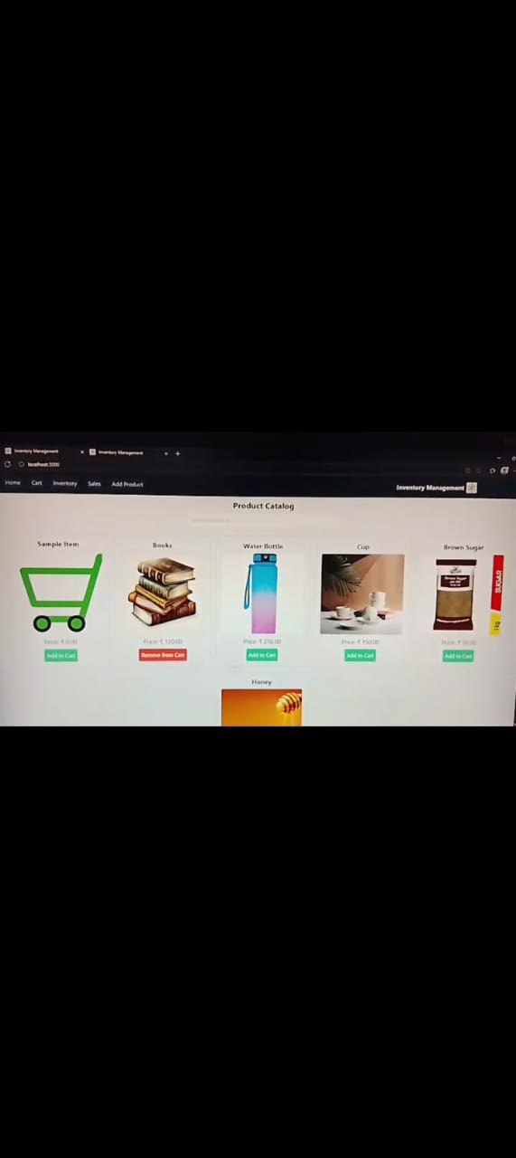

**12. Known Issues**

(Add any issues faced during development)

**13. Future Enhancements**

* Add payment gateway integration
* Generate sales reports and analytics
* Implement barcode scanning system